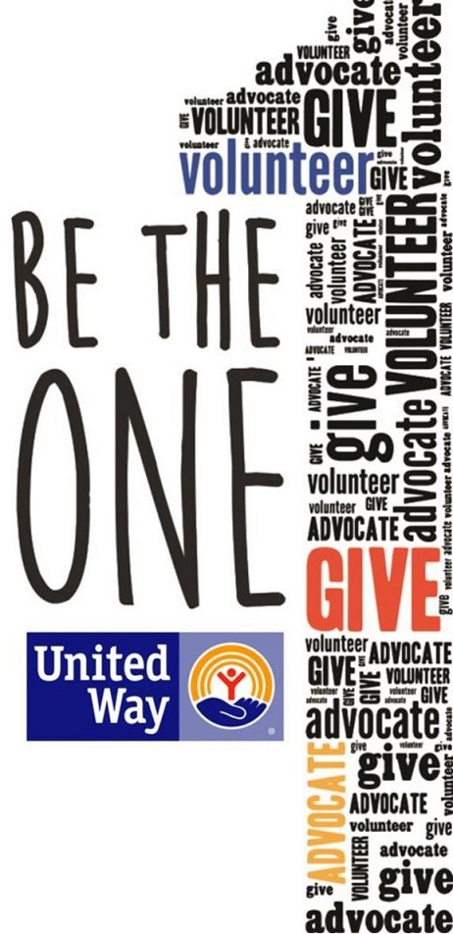

At the start of the campaign, we asked you to believe there is hope, and more than that, to BE the hope by committing to Be The One.

We are so appreciative of everything you all accomplished in the last <<XXX>> weeks! From the kick-off event, to the last pledge turned in, we have seen so much support for this UW Campaign. We are proud of everyone in this office who made a difference for someone in need.

Thank you so much for making this campaign such a fun success! Hundreds of lives will be touched thanks to your support.

Sincerely,  
<<CEO and ECC>>

“Alone we can do so little; together we can do so much.”-Helen Keller

#LiveUnited #BeTheOne