- July
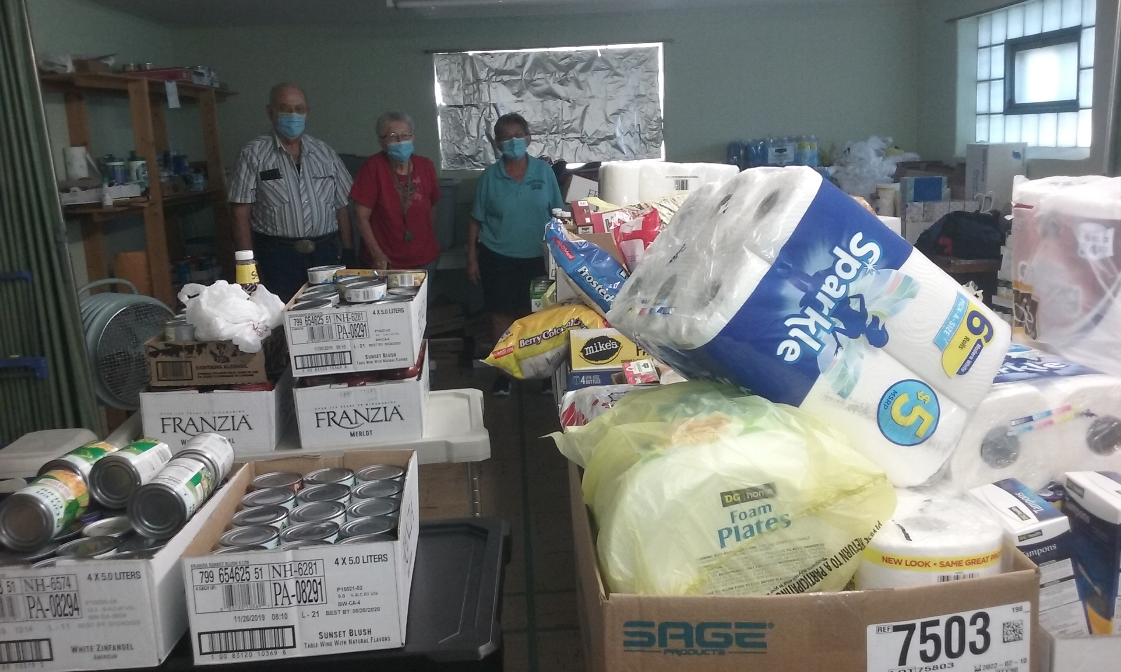
  - July 13th-Hoisington Chamber Coffee
  - July 22nd-Stuff the Bus Great Bend
  - July 26th-Stuff the Bus Hoisington

- August
  - August 5th-Kickoff Event-Dueling Pianos
  - August 9th-Stuff the Bus Ellinwood
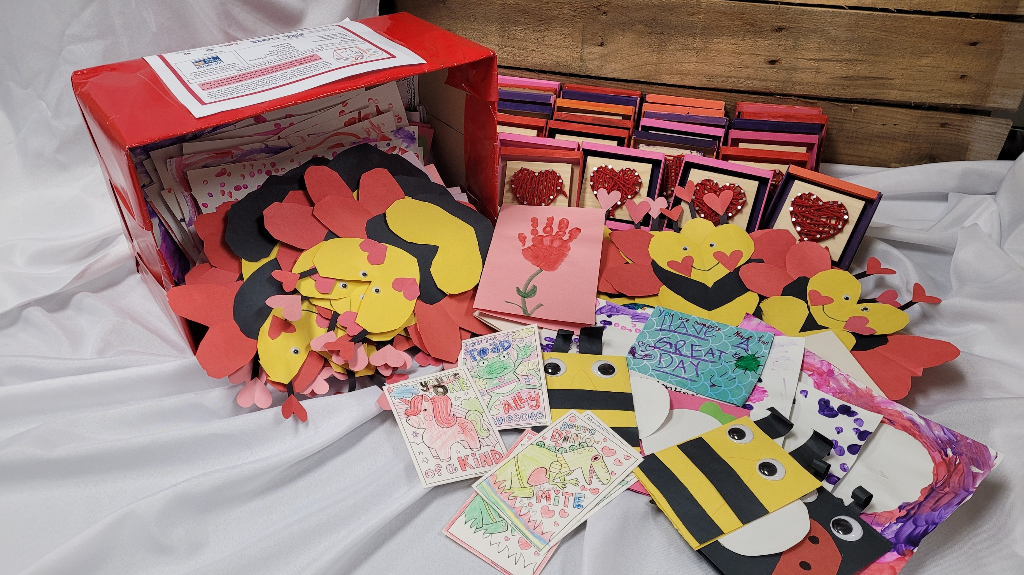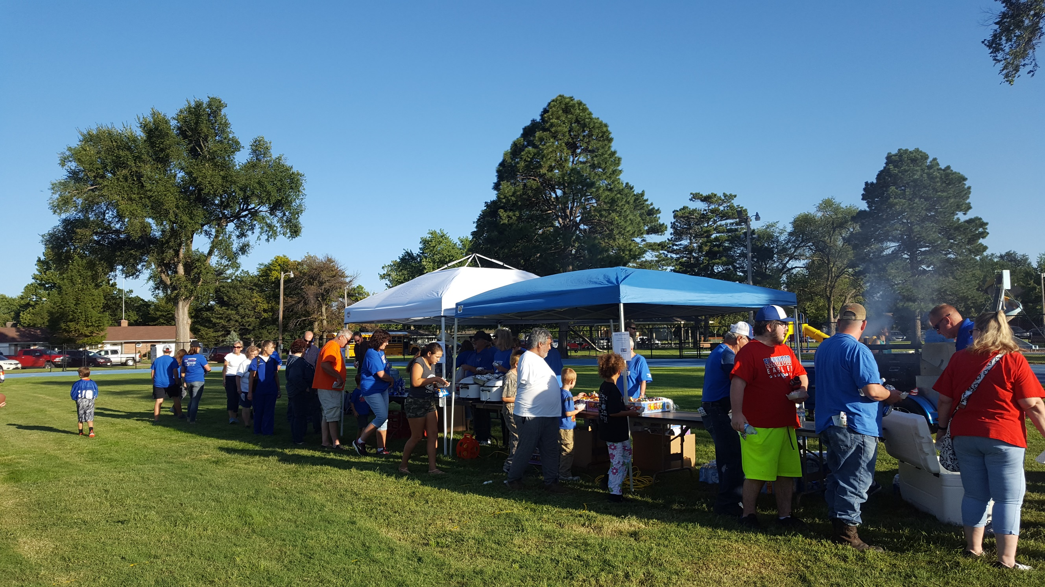
- September
  - September 1st-Hoisington Football Sno Cones
  - September 8th-Ellinwood Chamber Coffee
  - September 14th-Larned Chamber Coffee
  - September 15th-Ellinwood Football Ice Cream Social

- October
  - October 1st-Beer & BBQ at Dry Lake Brewing
  - October 18th-Reality U Great Bend

- November
  - November 2nd-Poverty Simulation
  - November 28th-Giving Tuesday

- January
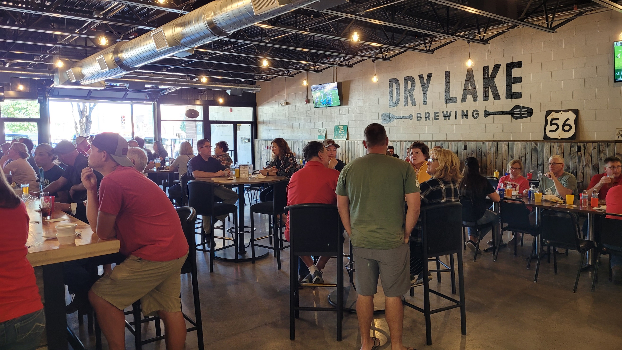
  - January 31st-Reality U Ellinwood (Hosting Central Plains, Larned, Hoisington, Otis-Bison, and Pawnee Heights)

- February
  - February 14th-Box of Love

- March
  - Dr. Seuss Day
  - March 22nd-#RealWorld
Ongoing Events
Laundry Love Great Bend, 3rd Saturday of each month
Laundry Love Larned, Final Wednesday of each month

