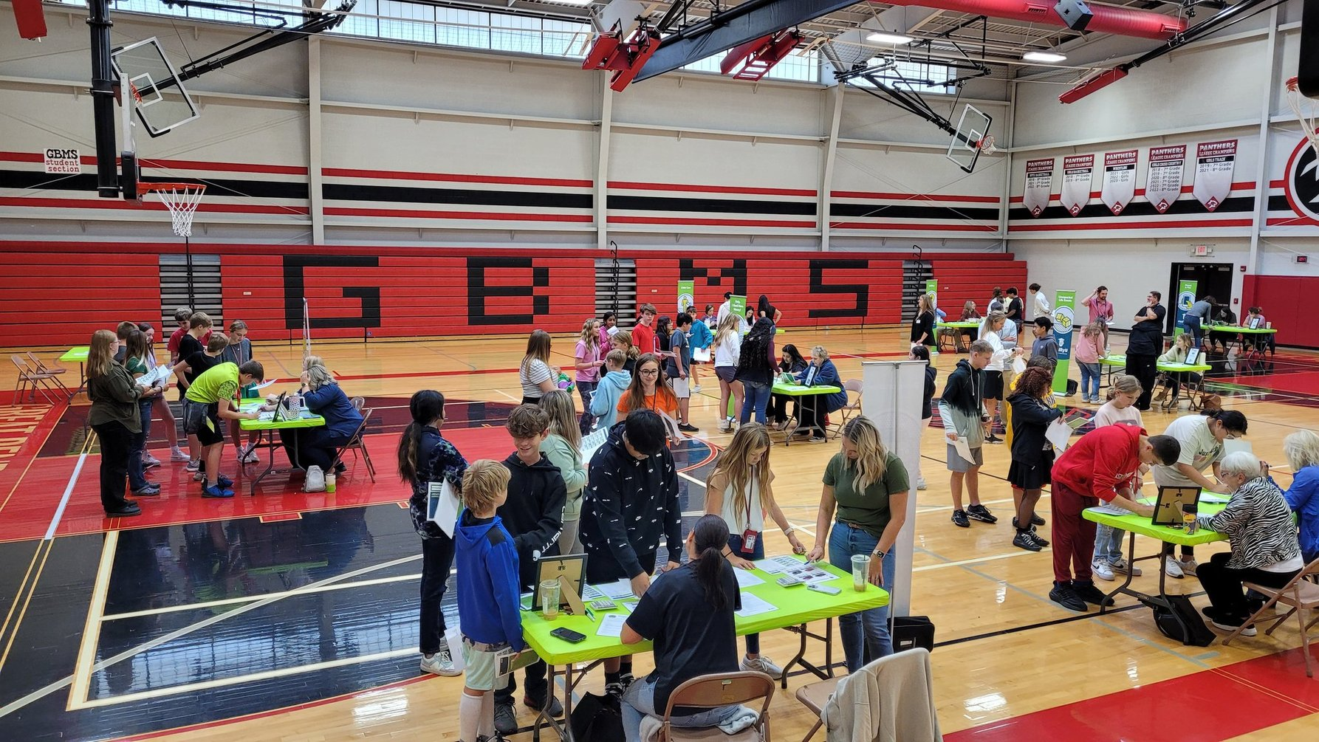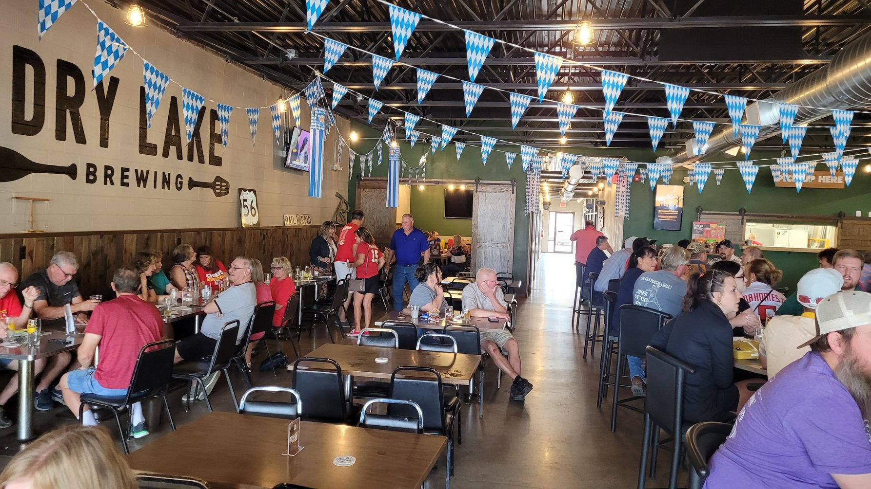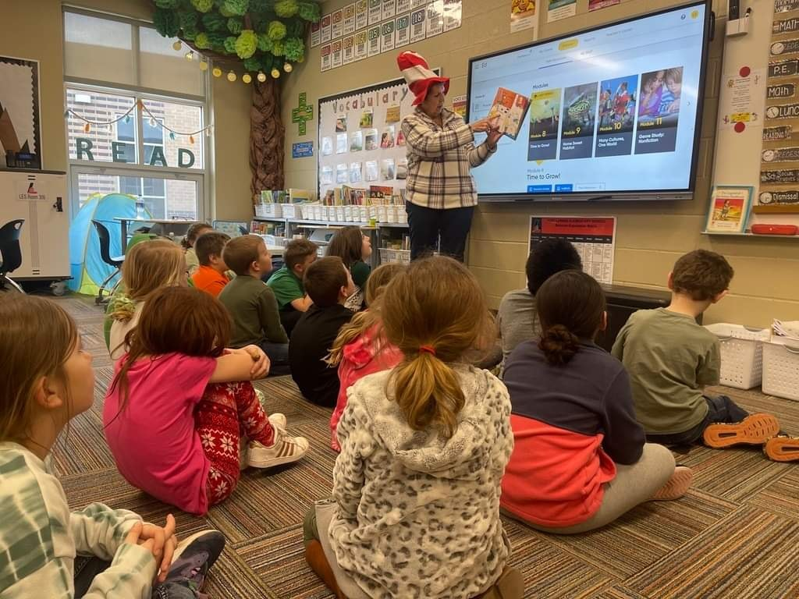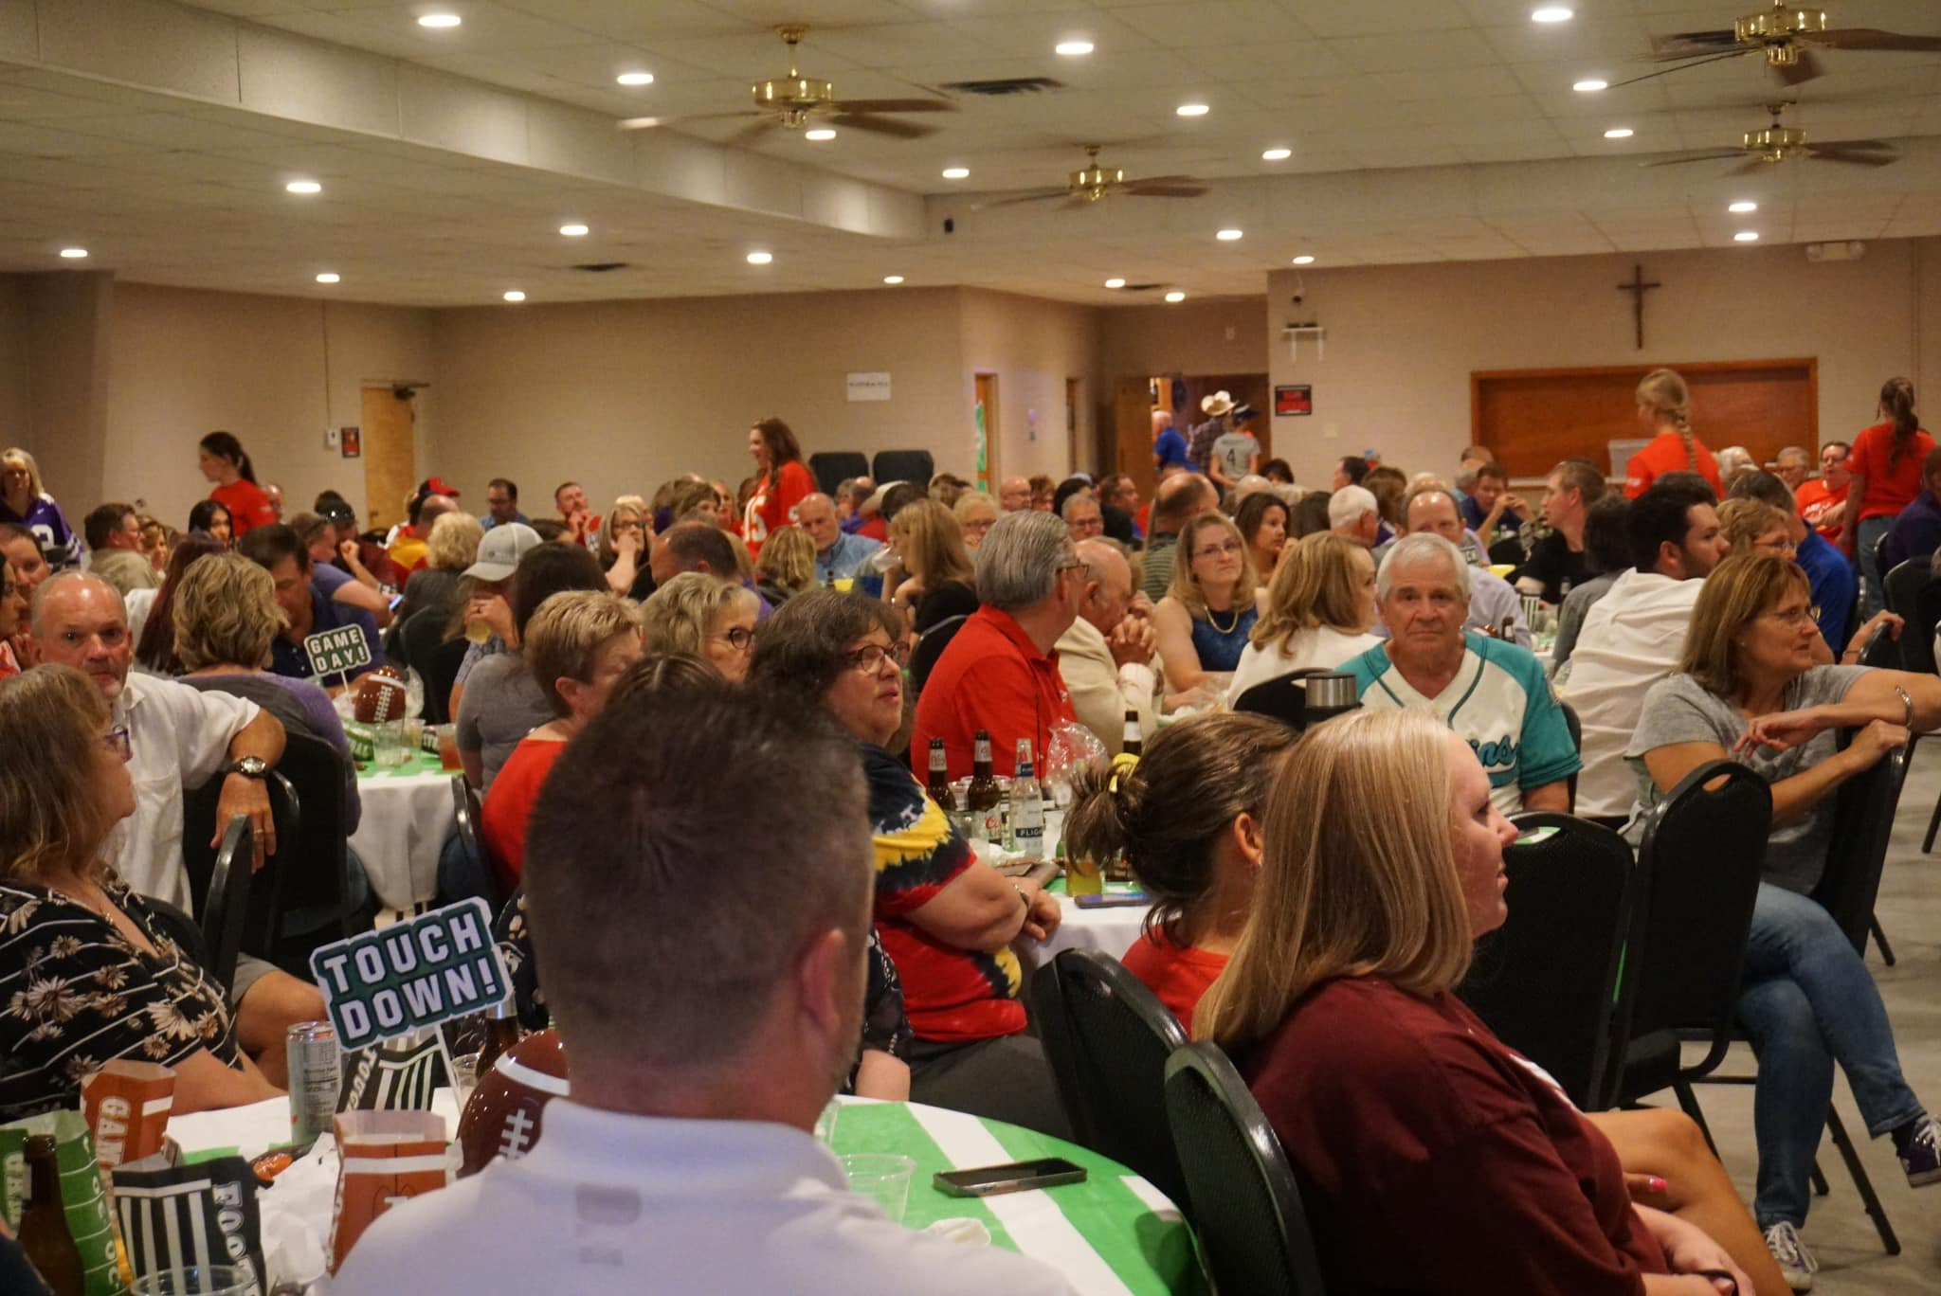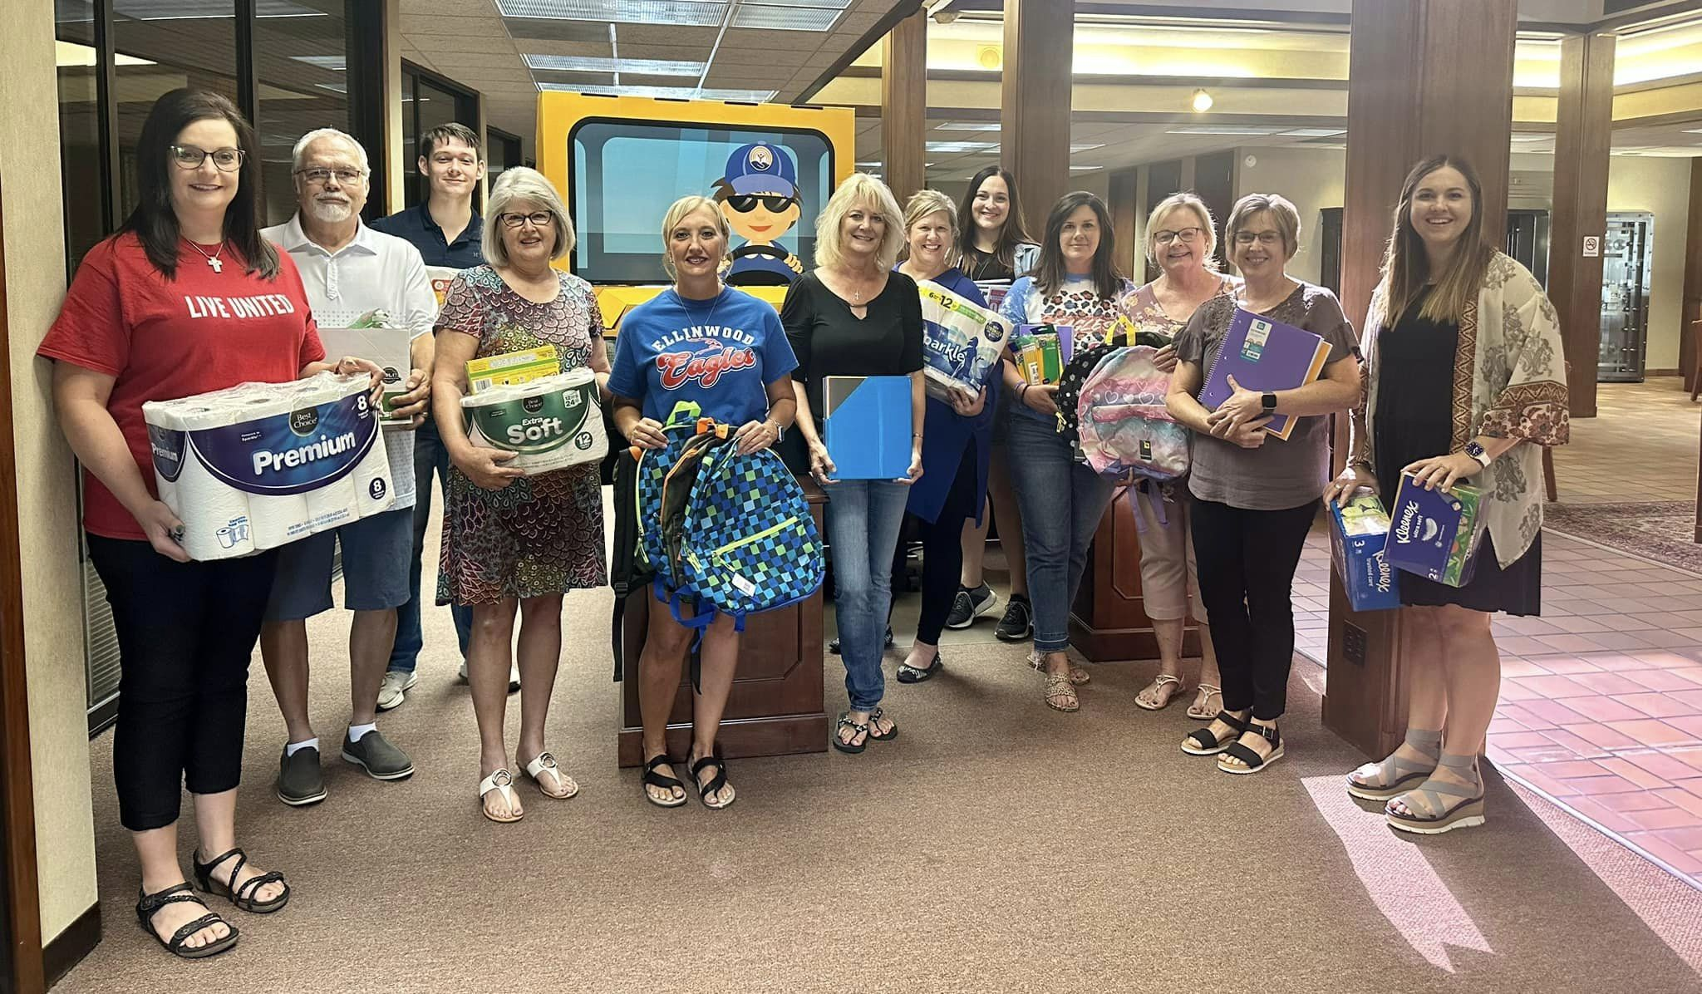

- July

  - July 13th-Stuff the Bus Great Bend
  - July 24th-Stuff the Bus Hoisington
  - July 30th-Stuff the Bus Larned

- August
  - August 1st-Hoisington Chamber Coffee, First Kansas Bank
  - August 3rd-Kickoff Event
  - August 14th-Stuff the Bus Ellinwood

- September
  - September 12th-Larned Chamber Coffee, location TBD
  - September 13th-Ellinwood Chamber Coffee, location TBD
  - Ellinwood Tailgate
  - Hoisington Tailgate
  - Larned Tailgate
  - Larned Chamber Coffee

- October
  - October 6th-Beer & BBQ
  - October 16th-Reality U Great Bend

- November

- December
  - December 3rd-Giving Tuesday

- January
  - January 22nd-Pawnee County Reality U, 8th & 10th graders
  - January 29th-Barton County Reality U, 8th & 10th graders

- February
  - February 14th-Box of Love

Laundry Love will be on the 3rd Saturday of each month in Great Bend at Discount Laundry from 10:00-2:00 and in Larned on the final Wednesday* of the month at Santa Fe Laundry from 4:00-6:00.

