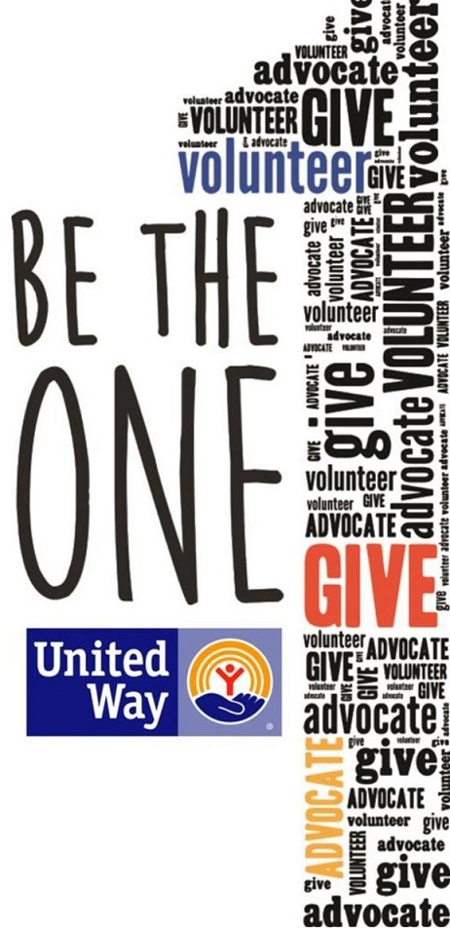

I love the United Way campaign, but let’s be honest: some of you still have questions. Where does the money go? Does my donation really make a difference?

The short answers are: where it’s most needed and ABSOLUTELY!

But let me break it down for you:  
**Where does the money go?**  
All donations to United Way benefit people in Central Kansas and support access to quality education, a stable income that can support a family, and good health.

Some initiatives – like Dolly Parton’s Imagination Library, Literacy Kits, Boxes of Love, Born Learning Trails, Reality U, and Hands Only CPR. Not to mention the financial support that UWCK

**Does my donation make a difference?**  
Absolutely! You might be amazed by how much good each dollar does.  
For example:

· For $5 a month you can provide a Box of Love to a dozen homebound seniors.

· For $10 per month you can provide Literacy Kits to a classroom of Pre-K students.  
· For $25 a month you can provide food for a family for a month through the Hoisington Food Bank.

· For $40 a month you can provide services to an at-risk youth, helping to get them back on track to a successful future.

· For $80 a month you can provide a Meals on Wheels lunch to one person for a month.

By donating to United Way of Central Kansas, you can rest assured that your dollars are staying local and are going to agencies with a proven track record.

“Alone we can do so little; together we can do so much.”-Helen Keller

#LiveUnited #BeTheOne